**Techniques of Analysis**

The researcher observed the store’s customer influx for 7 days or 168 hours and interviewed Matthew, the head of the store to gain data about the data management system his store used.

Questionnaires were also handed out to respondents. The questionnaires focused on finding which of the three (3) inventory systems are best suited for a company: manual, database or programmed. A questionnaire is a list of research questions designed to extract quantitative data. A questionnaire was used because large amounts of information can be collected from a large amount of people. It can be done in a short period of time and in a cost-effective way. The questionnaire consisted of ten (10) questions. There were eight (8) closed-ended questions and two (2) open-ended questions.

The total persons (population) who operate an inventory system in Georgetown are ~500 people. The sampling method was stratified random sampling: the researcher categorized people in the population by their years of experience in using inventory systems. Questionnaires were distributed to three (3) respondents from three (3) organizations that used inventory systems namely: Guyana Telephone & Telegraph Co Ltd – who used programmed, database and manual inventories, Starr Computers Inc – who used manual inventories, and Bounty Farm Ltd – who used programmed inventories. The questionnaires were handed out on the 9th of April, 2016. The questionnaires were collected on the 16th of April, 2016. Respondents of these companies were given a total of 7 days or 168 hours to complete the questionnaires. However, even after 7 days, some respondents provided very little information on open-based questions.

**Data Flow Diagrams (DFDs) – Context Level**

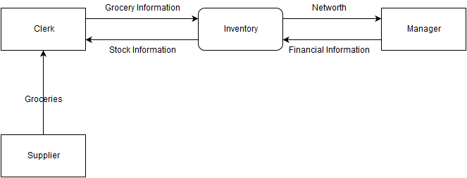

**Figure 1: Level-0 diagram showing data flow in Matthew’s Grocery Store’s workspace**

**Design Specification – User Interface Design**

Because the system has to be running 24 hours a day, it must be fast and easy to wake up from rest. For this reason, the researcher chose to use default system fonts as the typeface and a command line display that is always turned on.

Because no data must be deleted unless commanded by the user, the system must have a dedicated system which gives the program all authority over data.

Because the system must start up in a maximum of 6 seconds, the researcher used no background color, and left it as the default black and white text to start up more quickly which loading font data from libraries. The font used was the default system font which does not require to be retrieved from a library.

Based on all these constraints, a command-line user interface was used.

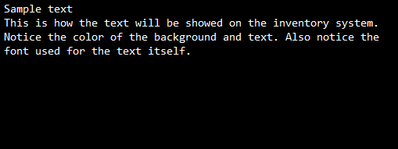

**Figure 8: Interface Design of the System**

The design includes a barcode sensor connected to a data management system. The laser lights act as indicators. This arrangement served to send messages regarding the grocery item (the barcode) to the data management system. The active device throughout this project is a barcode scanner. It is used to input data into the inventory, even though data passes through several systems before reaching the inventory. This design makes use of a repository system and its sub-systems. The design has many potential applications including storing, editing, and destroying grocery data.

Procedures for design

* Within the circuit was a barcode controller integrated circuit whose output was connected to POS system. To control this system, the circuit was programmed following the pseudocode shown in the Algorithm Design. When implementing this circuit, the function Locate was first called to locate previous inventory records. This is to load previous data so that the barcode scanner has data to operate upon, i.e. if there are no groceries, the stocks become negative.
* Afterwards a variable choice is inputted by the user that stores the user’s choice on operations needs to be undertaken by the problem.
* Next, a prompt was shown to verify if the user wants to continue the program.

Assessment of design

* To test the operation of the function Locate (), previous barcode data was manually added to a file and placed in a root folder. During this, it was verified that the developed hardware and software of the lab for this part was functioning smoothly.
* Whilst testing the variable choice, a lot of complication insisted, including wrong data type or no data at all. To debug this error, a character array of size 100 had to be used instead of a character. There was then a check to verify the input size. If the array size was greater than one, then and error message was displayed on the screen. Also, conditions were used to account for the various options, with an else command used to terminate any other false input.
* Initially, a recursion was used at the end of main (). However, this created a major complication in exiting the program as directly closing the program would be unsafe. Therefore, the continue prompt was put in place.

All in all, the barcode scanner worked satisfactorily in conjunction with the program (inventory) to bring about a working data management system.**Design Specification – Report Design**

**Figure 9: Bar Graph Showing the Popularity of the Various Inventory Types**

**Figure 10: Pie chart showing Limitations Proportions of the Various Inventory Types as indicated by Respondents**

This report presents a data management system that makes use of an inventory. It is used by Matthew’s Grocery Store. This system is being implemented because there is a problem with the grocery store where there is too much paperwork being done that is time-consuming and frustrating for the staff of the store. This is evident when the researcher observed the store for a period of seven (7) days or 168 hours and noticed a large influx of customers in the store. This observation was proved using the questionnaires. Various graphical presentations are provided above that support this proof. The manager of the store has realized that their numbers of customers are greater now than a decade ago. Therefore, after drawing conclusions from the data collected, a programmed data management system was hypothesized.